Privilege Escalation Attack Detection and Mitigation in Cloud Using Machine Learning
Cloud servers manage all data from centralized servers and often suffer from insider and outsider attacks. Outsiders attack are those attacks which sent by external hackers or attackers. Insiders attack are done by internal employees of cloud server management. In insider attack database administrator or server manager can alter any records or send secret mails to 3rd parties. To detect such attacks cloud server will log all internal employees’ activities such as sending mails, accessing files etc.
In propose paper to detect such insider attacks author of this paper employing ensemble machine learning algorithms such as Random Forest, LIGHTGBM, XGBOOST and ADABOOST. Among all algorithms LIGHTGBM is giving better accuracy and each algorithm performance is evaluated in terms of confusion matrix, accuracy, precision, recall and FSCORE.
To train and test all algorithm performance author has used CERT dataset which will contains all cloud access log information of employees. Each dataset record is associated with class labels 0 and 1 where 0 means normal and 1 means Insider attack.
In below screen showing dataset details and this dataset contains 830 columns
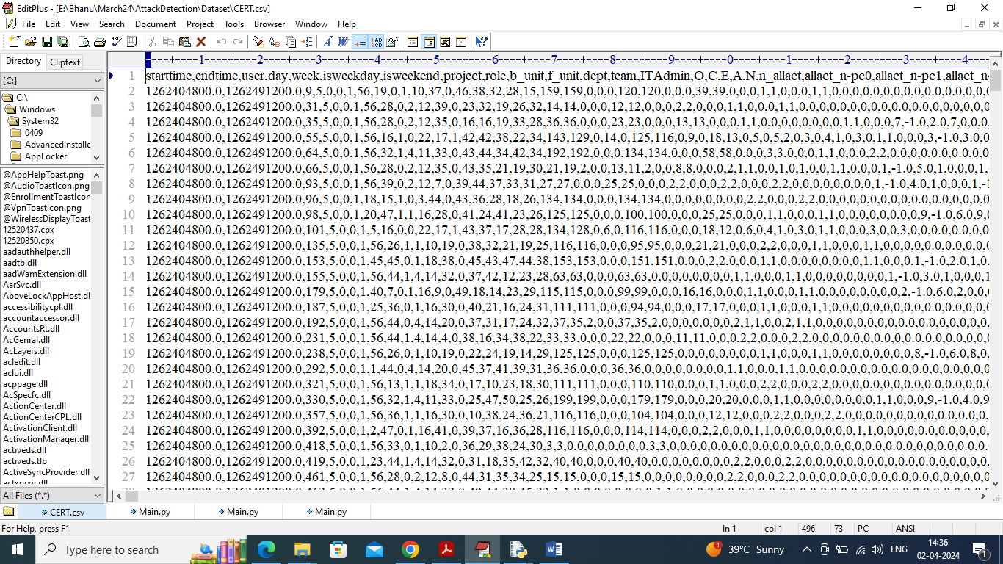
In above dataset screen first row contains dataset column names and remaining rows contains dataset values and in last column can see class labels as 0 and 1.
Extension Concept
In propose paper author has used all traditional Ensemble algorithms so as extension we have utilized CATBOOST algorithm which is one of the advance ensemble algorithms and can give better accuracy
To implement this project, we have designed following modules
- Upload CERT Database: using this module will upload dataset to application and then application will read all values and then visualize graph of normal and insider attacks
- Pre-process & Split Dataset: using this module will remove missing values and then shuffle and normalized values and then split into train and test where application using 80% dataset for training and 20% for testing
- Run Random Forest: 80% training data will be input to random forest algorithm to train a model and this model will be applied on 20% test data to calculate prediction accuracy.
- Run ADABOOST: 80% training data will be input to ADABOOST algorithm to train a model and this model will be applied on 20% test data to calculate prediction accuracy.
- Run XGBOOST: 80% training data will be input to XGBOOST algorithm to train a model and this model will be applied on 20% test data to calculate prediction accuracy.
- Run LIGHTGBM: 80% training data will be input to LIGHTGBM algorithm to train a model and this model will be applied on 20% test data to calculate prediction accuracy.
- Run Extension CATBOOST: 80% training data will be input to CATBOOST algorithm to train a model and this model will be applied on 20% test data to calculate prediction accuracy.
- Comparison Graph: will plot comparison graph between all algorithms
SCREEN SHOTS
To run project double click on run.bat file to get below screen
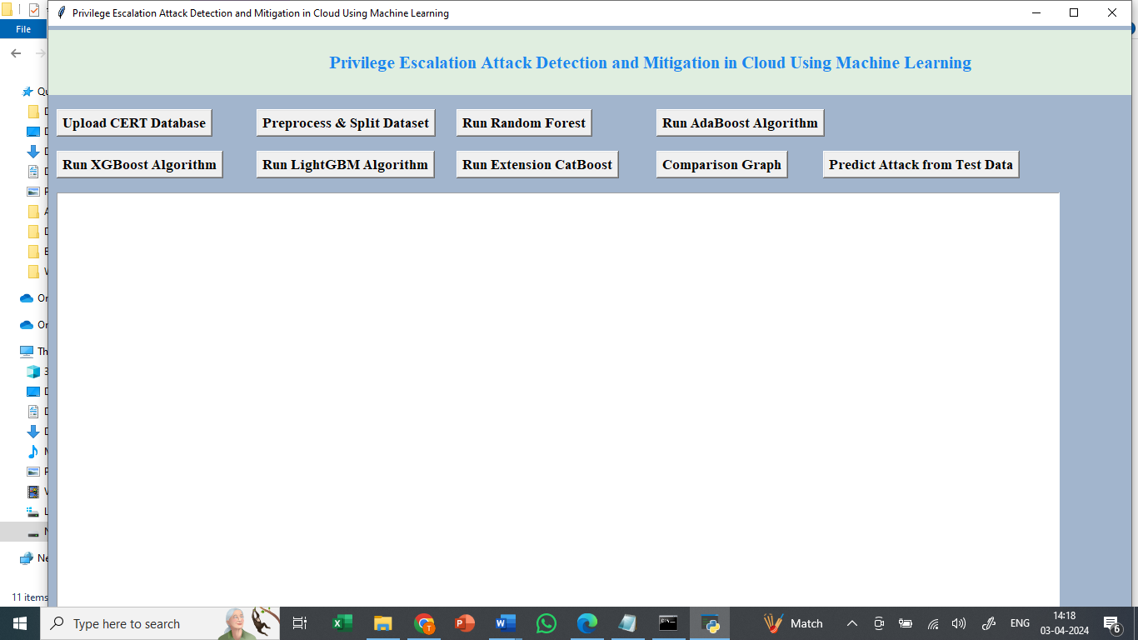
In above screen click on ‘Upload CERT Database’ button to upload dataset and get below page
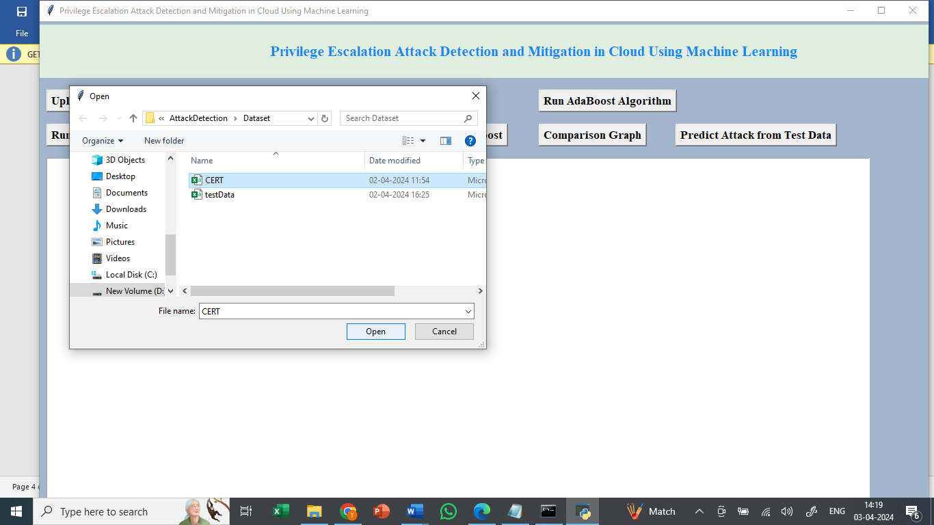
In above screen selecting and uploading ‘CERT’ dataset file and then click on ‘Open’ button to load dataset and get below page
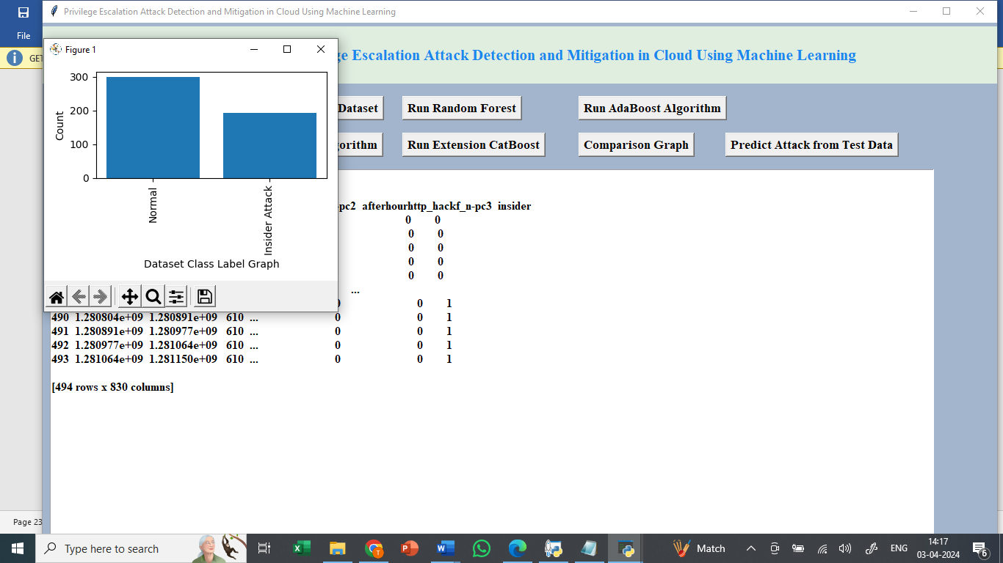
In above screen can see dataset loaded and can see dataset contains 830 columns and in graph x-axis represents class label types and y-axis represents number of instances under that class label and now click on ‘Pre-process & Split Dataset’ button to process dataset and get below page
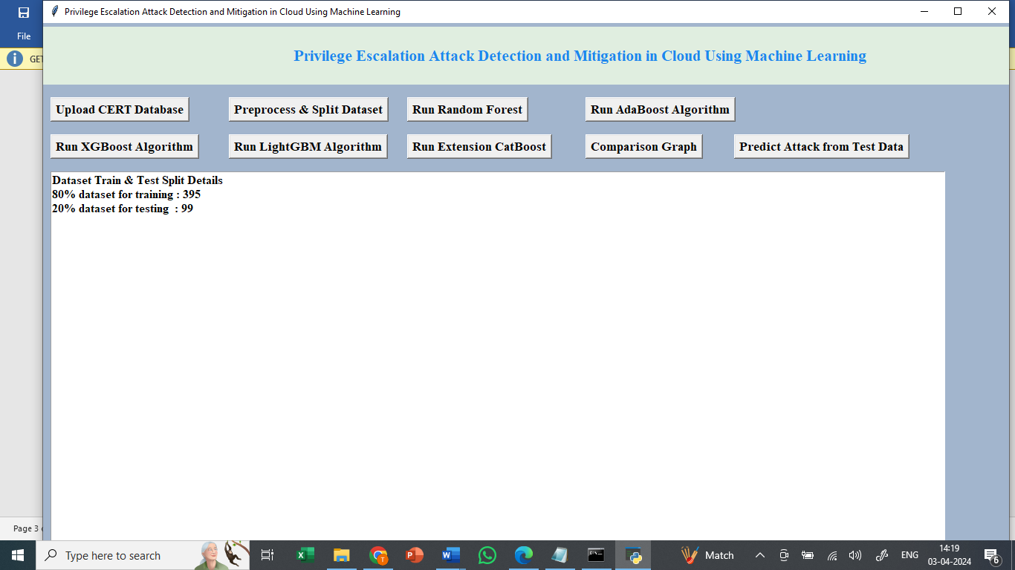
In above screen dataset processing completed and can see train and test size and now click on ‘Run Random Forest’ button to train Random Forest and get below output
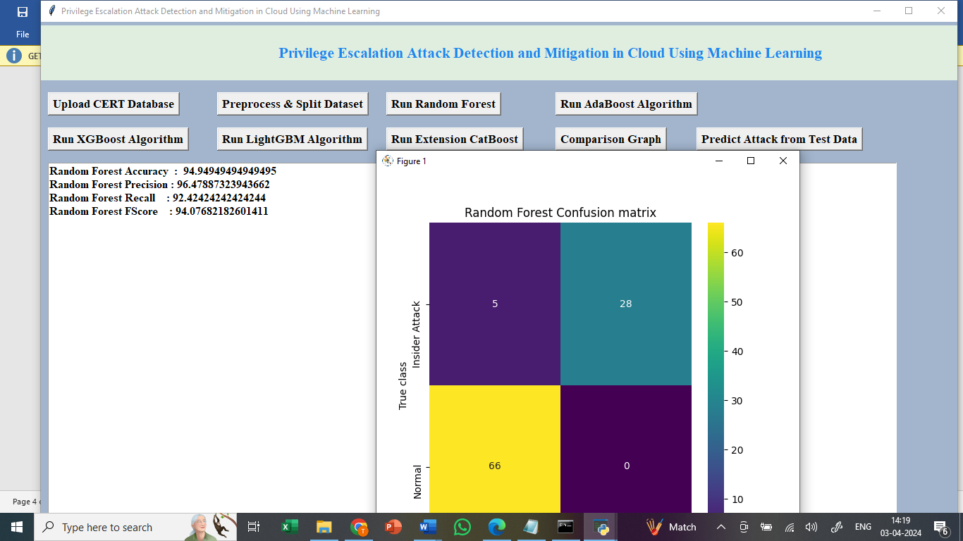
In above screen Random Forest got 92% accuracy and can see other metrics also and in confusion matrix graph x-axis represents Predicted Labels and y-axis represents True Labels and then yellow and green boxes in diagnol represents correct prediction count and blue boxes contains incorrect prediction count and now click on ‘Run ADABOOST’ button to get below output
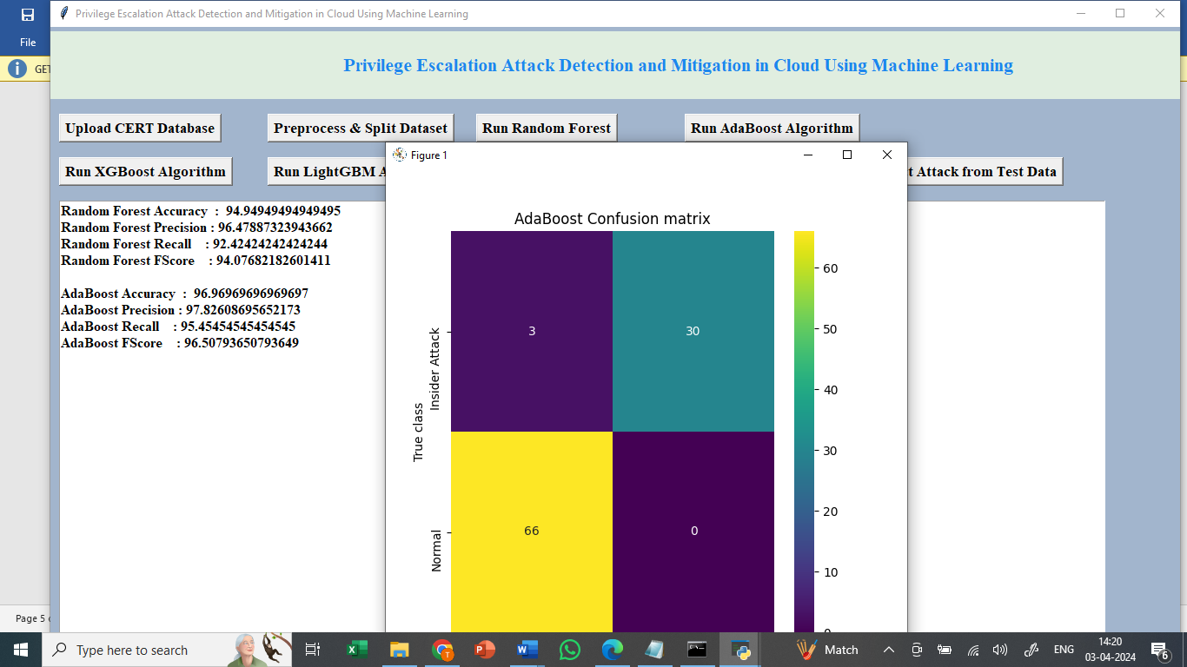
In above screen can see ADABOOST performance and now click on ‘Run XGBOOST’
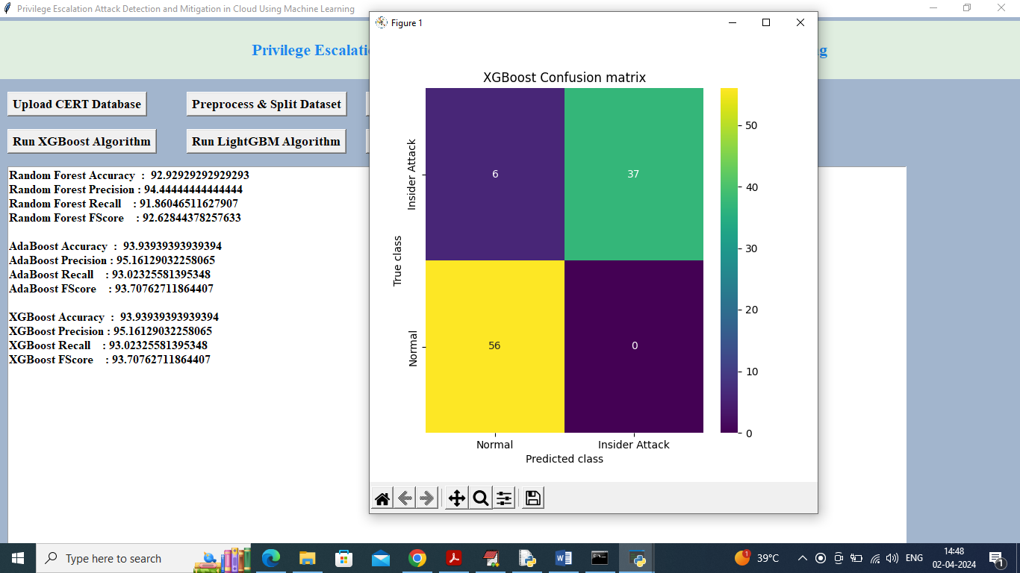
In above screen can see XGBOOST performance and now run LIGHTGBM
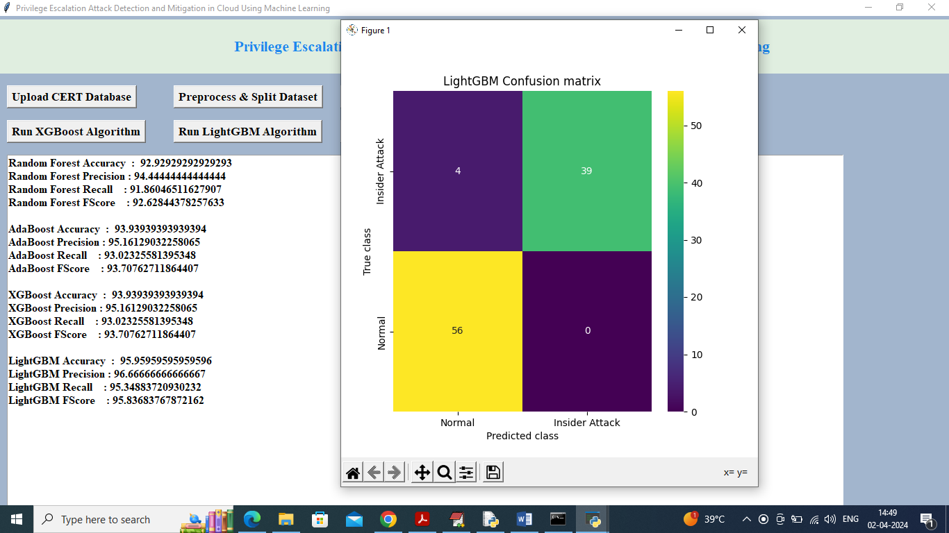
In above screen LIGHTGBM got 95% accuracy and now run CATBOOST algorithm to get below output
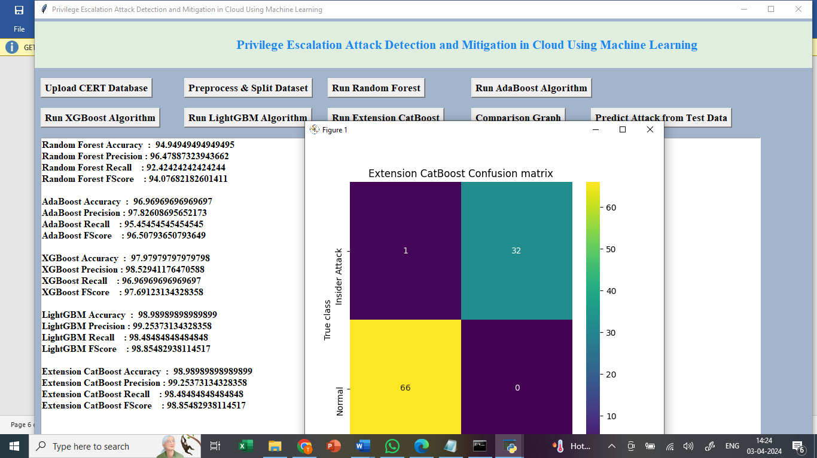
In above screen extension CATBOOST got 97% accuracy and now click on ‘Comparison Graph’ button to get below graph
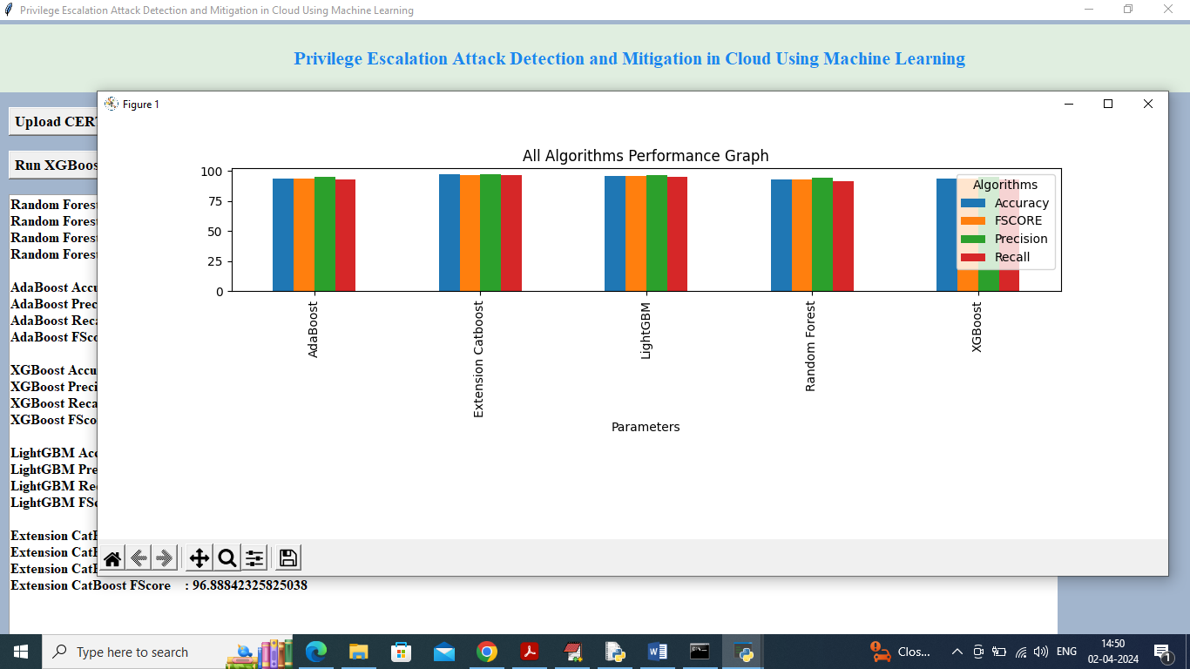
In above graph x-axis represents algorithms names and y-axis represents accuracy and other metrics in different colour bars and in all algorithms extension got high performance. Now Click on “Predict Attack from Test Data”
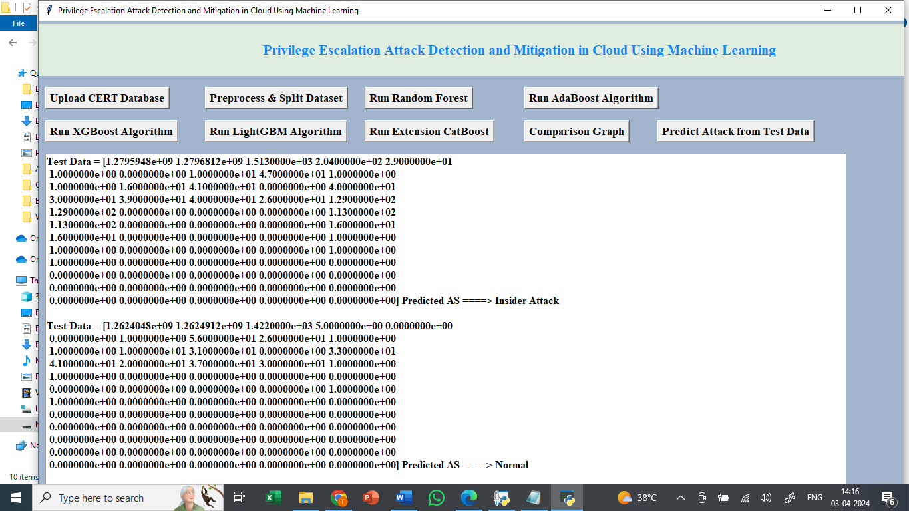
In above screen using extension CATBOOST algorithms we got the predicted value from the Test data as normal or Insider Attack.

Note: author has used huge dataset in GB size and we cannot train such long dataset in normal laptop so we have used some amount of data from whole 2 GB dataset so due to this reason accuracy will vary little from base paper

